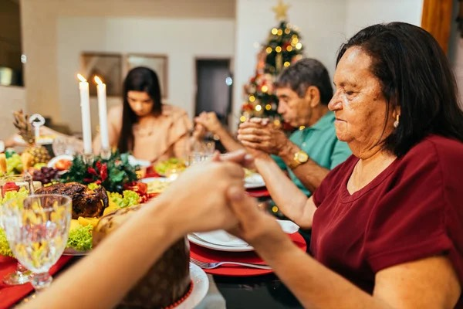
Family truly is one of God’s greatest gifts to us and a precious treasure. Our faith sees the family, whether young and just beginning or with adult children out of the home, to be the domestic church. In the words of Pope Benedict XVI:

“It is in the family that peacemakers, tomorrow’s promoters of a culture of life and love, are born and nurtured…”

It is never too soon and never too late to share, teach, enrich our families with the love that God has for each of them. Advent, preparing for the birth of Christ into our hearts and minds, is a perfect time to refresh and/or begin again, which is a common human trait God knows well, that life long journey of growing closer to God through our faith, our prayer, and our traditions.
Imagine offering your family a deeper relationship with God as a gift this Advent season. Advent, is a season of waiting for the birth of our Savior. Prayer, too, is a time of waiting, watching, and listening for God the Father, His son, Jesus, and the Holy Spirit to enter our lives in a new and meaningful way.
Communication, talking and spending time together, is the way we, as humans, form deeper relationships with each other. It’s the same with God! After all, he did take on the the flesh of man in his son, Jesus.
If spending time, talking/ praying with God is a new step for you or loved ones, it is fine to suggest just a few short moments a day as a way to begin. It can be as short as two minutes (and of course can be more than once a day) as a starting point for those out of practice or when you are having one of those whirlwind days without a moment to spare. Below are some samples to begin prayer but your own heartfelt, awkward as they may seem, words are the best.
Making the sign of the cross (slowly and reverently) is a prayer…(Wait, watch, listen) Jesus, Emmanuel, watch over me, protect me. (Wait, watch listen) (Use your own words…God the Father, Jesus his son, and the Holy Spirit are listening and loving this time with you. They have been waiting for you!)

Consistency is the key to start a deeper relationship with God. God’s time is not like our time so if we simply decide to make the time each day to talk/pray with him he will make very good use of the time we give to him.
Advent traditions: suggestions for additional prayer time for you and your family.
Angel tree: Our Angel tree gifts the HUGS organization of Hawaii. HUGS supports Hawaii families with a child up to age 21 who has been diagnosed with a life-threatening illness or disease.
Advent Wreath follow this link for the history. Make one for home!
Advent at home follow this link for home ideas for children of ALL ages.
St. Andrew Christmas Novena- follow link for the novena.
At Holy Trinity we support and sustain a culture of LIFE. If you have ideas and suggestions to share about activities or topics to pursue, please contact Debbie at dkula@rcchawaii.org

